**Proposal Cover Page**

Group Member:_Zachary_Snyder____________________________ Date:_10/28/14__

Group Member:_David_Carpenter___________________________ Date:_ 10/28/14_

Group Member:_Ajin_Sunny_______________________________ Date:_ 10/28/14_

Group Member:_Carrie_Bass_______________________________ Date:_ 10/28/14_

Group Member:_Suzanne_Hoover___________________________ Date:_ 10/28/14_

**Section I** - Problem Definition ___.35_____ (/1 point)

A. Brief problem definition

B. TOH for client and target TF for circuit design

C. Complete design specifications/constraints

**Section II** - Top-Level Design ___.8_____ (/1 point)

1. Presentation of block diagram of top-level design
2. Description of the purpose and function of each block. Description should convince reader that design is compatible with target TF.

**Section III** - Time-Table ___2.7_____ (/3 points)

A. Break-down of project into smaller sub-tasks  
B. Distribution of effort (primary responsibility for each member)  
C. Tentative time schedule for sub-tasks in order to complete project by required date

**Appendix I** – Measurement of Client TOH ___1.8_____ (/2 point)

A. Set Up of Measurement Equipment/Environment

B. Design of Test Signals

C. Computation of final TOH from measured data.

**Preliminary Total: ___5.65_____** (/7 points)

**Format** × ___.95_____ % (/100 %)

A. Technical presentation  
B. Grammar, Spelling, Succinctness

**Total: _5.38_______** (/7 pts)

**Section I.A**

The hearing ability of a person is different for each individual. When creating hearing aids for a client, it is important to determine the hearing deficiencies upheld by a particular individual. The client’s threshold of hearing (TOH) is compared to the normal TOH to determine how to account for the hearing deficiencies at particular frequencies using a number of different filters that will be able to provide the necessary gain allowing the client to modify their TOH to match the normal TOH. Therefore, a customized hearing aid filter is designed for a client to uphold special features to amplify sound non-uniformly over the hearing spectrum. This allows for the frequency dependent on hearing deficiencies to be compensated.

**Section I.B**

The threshold of hearing for the client was determined using the method outlined in Appendix I. **Table 1** shows the dB gain at each frequency. **Figure 1** shows the TOH for the client based on the dB gain. **Figure 2** shows the target transfer function based on the dB gain.

**Table 1:** dB gain at each frequency

|  |  |
| --- | --- |
| Transfer Function | |
| Frequency | dB |
| 200 | 2.5 |
| 228.3 | 50.554 |
| 260.61 | 45.495 |
| 297.48 | 42.568 |
| 339.58 | 37.694 |
| 387.63 | 36.411 |
| 442.48 | 31.756 |
| 505.1 | 30.76 |
| 576.57 | 32.397 |
| 658.16 | 22.608 |
| 751.29 | 19.287 |
| 857.6 | 17.304 |
| 978.95 | 18.838 |
| 1117.5 | 21.109 |
| 1275.6 | 22.439 |
| 1456.1 | 10.811 |
| 1662.2 | 10.179 |
| 1897.4 | 6.449 |
| 2165.9 | 9.6529 |
| 2472.3 | 1.2446 |
| 2822.2 | 2.2326 |
| 3221.5 | 3.7927 |
| 3677.4 | 0 |
| 4197.8 | 3.6143 |
| 4791.8 | 7.7961 |
| 5469.8 | 6.476 |
| 6243.8 | 7.9971 |
| 7127.4 | 13.747 |
| 8135.9 | 16.814 |
| 9287.2 | 20.021 |
| 10601 | 23.562 |
| 12102 | 16.317 |
| 13814 | 15.5 |
| 15769 | 49.673 |
| 18000 | 2.5 |

**Figure 1:** The threshold of hearing plot for the client

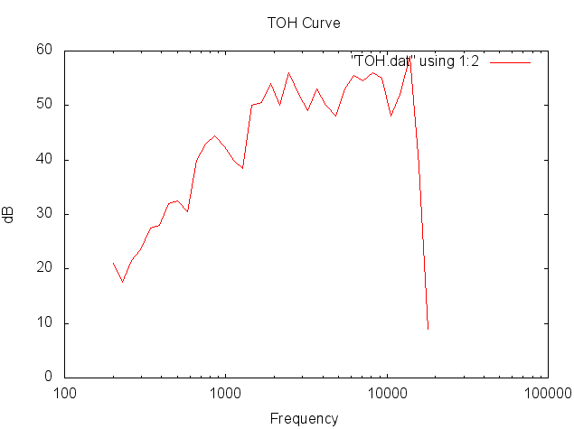

**Figure 2:** The target transfer function

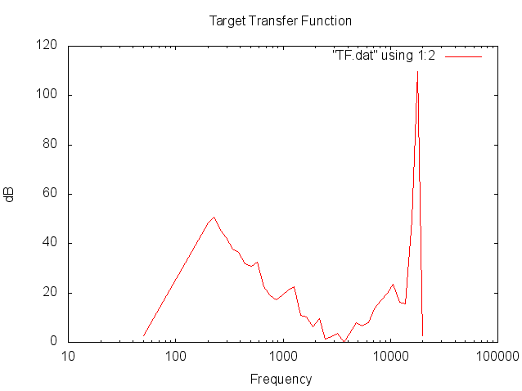

The desired transfer function data was found by using a script to find the difference between the normal TOH and the client’s. From this data it was then normalized to find the transfer function.

**Section I.C**

The design specifications for the customized hearing aid will uphold 5 filters. This includes one summing amp to add the data and adjust the total gain. As a result, the summing amp will uphold the constraint of being below 3dB at each end. This procedure can be completed by adding the second order band pass at each end from 200 – 300 Hz and 17,000 – 18,000 Hz. In addition, three second order band pass filters will be used to smooth out peaks at 400 – 500 Hz, 725 – 1650 Hz, and 1800 – 2100 Hz. The last op-amp to be used will be in the form of a summing amplifier.

The input and impedance will respectively be 50 Ω and 2 MΩ.

**Section II.A**

The block diagram below, **Figure 3**, represents the top-level design for our hearing aid.

**Figure 3:** The top-level block diagram

Second order band pass filter (200-300 Hz)

Second order band pass filter (400-650 Hz)

Second order band pass filter (17000-18000 Hz)

Second order band pass fiter (725-1650 Hz)

Second order band pass filter (1800-2100 Hz)

Summing Amp

Sound Input

Sound Output

**Section II.B**

The block diagram in Section II.A shows the top-level design for the hearing aid starting with the sound input feeding into the necessary filters followed by a summing amp and then the sound output. The top and bottom filters are second order band pass filters for the frequencies 200-300 Hz and 17000-18000 Hz. These filters ensure that there are 3 dB bounds on both edge frequencies. The three remaining filters are also second order band pass filters for the frequencies 400-650 Hz, 725-1650 Hz and 1800-2100 Hz. The filters each represent a visible dip in the transfer function plot at the frequencies mentioned. The five filters are then combined using a summing amp after which the sound is output.

The optimization process included will use the “fit” feature of gnuplot. This command uses the Non-Linear Least Squares Marquardt-Levenberg algorithm to fit arbitrary functions to data. The idea is that the transfer functions have to be derived for the circuits that are intended to be used in terms of the circuit parameters, and tell the engine to fit using the circuit parameters. The engine will not only tell us the optimal parameters, or close to optimal, but will give the RMS error, variance error, and other keen parameters.

**Section III.A**

The work is being split into functional blocks.  Each block is centered around a tool, so that each person can specialize, and work at the same time.  The different blocks are PSpice, writing the report, Gnuplot, and more specifically choosing the transfer function

**Section III.B**

The distribution of tasks is as follows:

Zachary Snyder – gnuplot (optimization)

David Carpenter – Transfer Function

Ajin Sunny – Matlab

Suzanne Hoover – pSpice

Carrie Bass – Report

**Section III.C**

The following table, **Table 2**, defines the due date for each objective for the completion of the project and lists the person who is in charge of that task.

**Table 2**: Defines the date, task and person for the project.

|  |  |  |
| --- | --- | --- |
| **Due Date** | **Objective** | **Person** |
| 11/7/14 | Go from general form of the transfer function to specific filter circuits | David Carpenter |
| 11/12/14 | Optimize the circuit | Zachary Snyder |
| 11/14/14 | pSpice simulation | Suzanne Hoover |
| 11/19/14 | Matlab simulation | Ajin Sunny |
| 11/21/14 | Final Report | Carrie Bass |

**Appendix I.A**

The client’s hearing test was performed in the basement of the William T Young Library in a closed room. There was minor disturbance from people passing by outside the room but otherwise the room was quiet.

The sample tones were played from the speakers of a Macbook Pro Retina 13 inch laptop (model # A1502 ME864 865 866) without headphones. The tones were only played forward. The volume was calibrated at the 3221.53 Hz sample because hearing is supposed to be most sensitive around this frequency. The volume was calibrated so that 26 tones were heard at this frequency which was a volume level of 18.75%. Each sample was played four times and an average count of the number of tones heard was calculated.

**Appendix I.B**

The sample tones were created on Matlab using a logspace function that created 35 evenly spaced points from 200 Hz to 18000 Hz. Based on the experimental design homework, it was decided that 35 test frequencies would provide enough data to determine the threshold of hearing. The sample tones were saved as .wav files.

**Appendix I.C**

The computation of the final TOH was done using the Matlab scripts TF.m and thrhearvals.m.

The script thrhearvals.m is called with an argument that is the frequency and returns the estimated dB level that corresponds to the threshold of hearing. The function in this script was called in the TF.m script.

The script TF.m created a vector that stored the 35 frequencies. There was also a vector that stored the average count at each frequency. Because the dB step size was 2 dB, the vector that stored the average count was converted to be in dB by multiplying each value by 2. To find the transfer function, the thrhearvals function return value was subtracted from the value in the vector of the average counts that corresponded to the same frequencies. The transfer function was then normalized so that the gain was the most sensitive when the frequency was around 3 kHz. The frequencies and the corresponding dB value were then printed.

The data below represents the test frequencies for four trials from 200Hz to 18 kHz:

|  |  |  |  |  |  |
| --- | --- | --- | --- | --- | --- |
| **Frequency (Hz)** | **Trial 1 (ct)** | **Trial 2(ct)** | **Trial 3 (ct)** | **Trial 4 (ct)** | **Average** |
| 200 | 10 | 11 | 11 | 10 | 10.5 |
| 228.301 | 9 | 9 | 9 | 8 | 8.75 |
| 260.607 | 10 | 11 | 12 | 10 | 10.75 |
| 297.484 | 10 | 12 | 12 | 13 | 11.75 |
| 339.579 | 13 | 14 | 13 | 15 | 13.75 |
| 387.631 | 16 | 13 | 14 | 13 | 14 |
| 442.483 | 17 | 17 | 14 | 16 | 16 |
| 505.096 | 16 | 17 | 16 | 16 | 16.25 |
| 576.57 | 14 | 15 | 16 | 16 | 15.25 |
| 658.157 | 19 | 20 | 20 | 21 | 20 |
| 751.289 | 22 | 22 | 20 | 22 | 21.5 |
| 857.6 | 23 | 23 | 20 | 23 | 22.25 |
| 978.955 | 21 | 22 | 22 | 20 | 21.25 |
| 1117.482 | 19 | 20 | 21 | 20 | 20 |
| 1275.611 | 19 | 18 | 20 | 20 | 19.25 |
| 1456.115 | 25 | 26 | 25 | 24 | 25 |
| 1662.163 | 26 | 27 | 24 | 24 | 25.25 |
| 1897.367 | 26 | 27 | 28 | 27 | 27 |
| 2165.853 | 23 | 26 | 25 | 26 | 25 |
| 2472.331 | 28 | 27 | 28 | 29 | 28 |
| 2822.178 | 27 | 27 | 26 | 24 | 26 |
| 3221.53 | 26 | 25 | 23 | 24 | 24.5 |
| 3677.391 | 27 | 26 | 27 | 25 | 26.25 |
| 4197.76 | 25 | 26 | 24 | 25 | 25 |
| 4791.763 | 26 | 24 | 25 | 21 | 24 |
| 5469.82 | 29 | 27 | 24 | 26 | 26.5 |
| 6243.825 | 26 | 25 | 30 | 30 | 27.75 |
| 7127.356 | 27 | 27 | 28 | 27 | 27.25 |
| 8135.911 | 29 | 28 | 28 | 27 | 28 |
| 9287.181 | 25 | 28 | 28 | 29 | 27.5 |
| 10601.361 | 25 | 23 | 23 | 25 | 24 |
| 12101.504 | 25 | 26 | 26 | 27 | 26 |
| 13813.924 | 29 | 30 | 29 | 30 | 29.5 |
| 15768.66 | 19 | 20 | 20 | 19 | 19.5 |
| 18000 | 4 | 5 | 4 | 5 | 4.5 |

**References**

<http://theochem.ki.ku.dk/on_line_docs/gnuplot/gnuplot_21.html>